*DESIGN OF MY PROGRAM:*

***PSEUDOCODE:***

Start:

Enter number of Users

If user number entered < or > 4 than print “file not found”

Else

Take input from users to enter Sunday Fares One by One.

Take User 1 input

Take User 2 input

Take User 3 input

Take User 4 input

Store the input values of the Users for Sunday (Sun) in an array

Read the text (.txt) file containing Mon to Sat Fares data with array

Calculate the Total Fares of each Users (from Mon to Sun)

Sort the Fare values in descending order and

Store it in the output text file using array

Display the User Fares data (from Mon to Sun) and Total fares on screen

Stop

***FLOW-CHART:***

Enter no. of Users

*File Not Found*

*No. of Users = 4*

No

Enter Sunday Fares for Each Users

***Sunday Fares > 2.7***

Yes

No

Read Sunday Input Values

*Store in the Output File*

*Read Text File (fares data from Mon to Sat)*

*Calculate the sum of values Mon to Sun for each Users*

Sort the values in descending order in output txt file

Display the Data on the Screen

**PROGRAM TEST DATA REVIEW:**

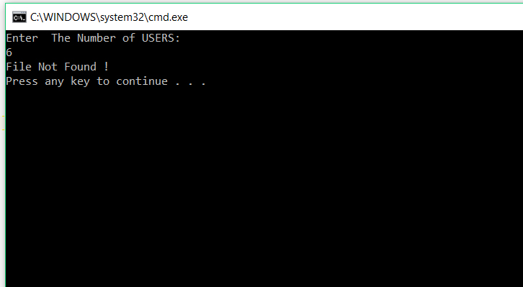

It starts with asking user to enter number of users i.e., 4 (as there are 4 users) which is already assigned in the array size. If user enter any number other than 4 than program says: “file not found” as shown beside in the figure.

After entering 4, it asks to enter Sunday Fares for each 4 users one by one; if user enters values greater than 2.7 than it ask to enter value again until the user enters less than or equal to 2.7

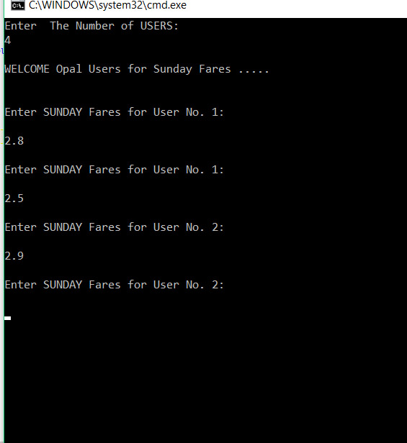

After whatever the values are entered by the users (but <= 2.7) than the program displays all the data Fares from Monday to Sunday and Total Fares. Also, the values in descending order are displayed on the screen.

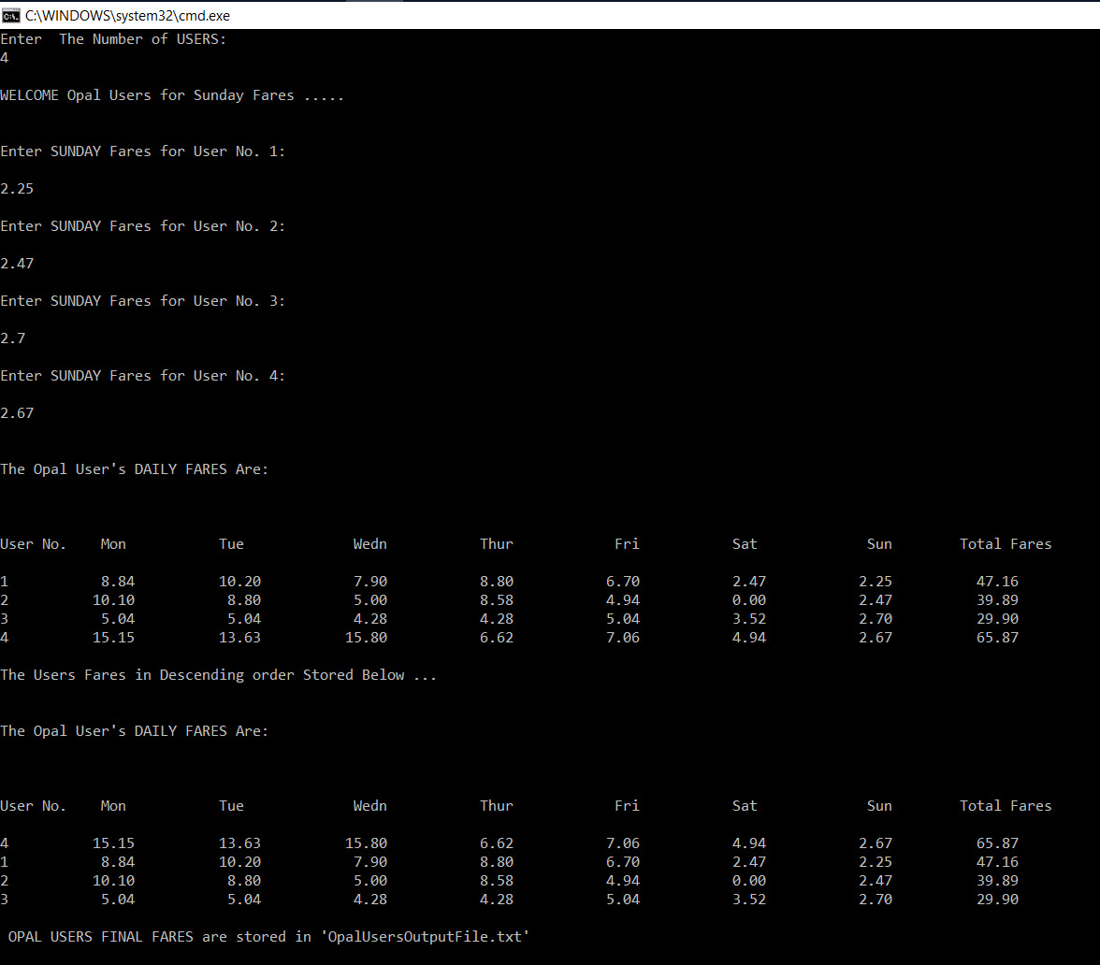

Next test example:

